The Effect of New Market-Rate Housing on the Low-Income Housing Market
Research conducted by Evan Mast (University of Notre Dame)

Housing costs and the share of income spent on housing are rising rapidly in many large cities, inspiring a heated debate on the appropriate policy response. “Yes-In-My-Backyard” (YIMBY) groups advocate for market-based strategies that relax regulation and increase housing construction. Opposing groups argue that the YIMBY position is flawed, claiming that unsubsidized new housing is too expensive to affect affordability for middle- and low-income households. This research project uses data on individual address histories to study how new market-rate housing construction affects the market for housing in middle- and low-income neighborhoods.

The Ripple Effect of Migration Chains

A “migration chain” mechanism could link expensive new housing to the market for cheaper types of housing. Some households who would have otherwise occupied cheaper units move into new units, reducing demand and lowering prices for the units they leave vacant. The process iterates when a second round of households moves into the units the first round left vacant. This ripple effect spreads out further and further, eventually reducing demand and prices in middle- or low-income areas. Moreover, this mechanism could operate relatively quickly, since it does not require new housing to depreciate until it becomes affordable.

However, the strength of this mechanism is an empirical question. If different parts of the housing market (like new construction and low-income neighborhoods) are strongly separated, with little cross-migration, the chain may never actually reach areas most in need. The unique address history data allows me to produce several pieces of evidence that suggest that migration chains are an important force.

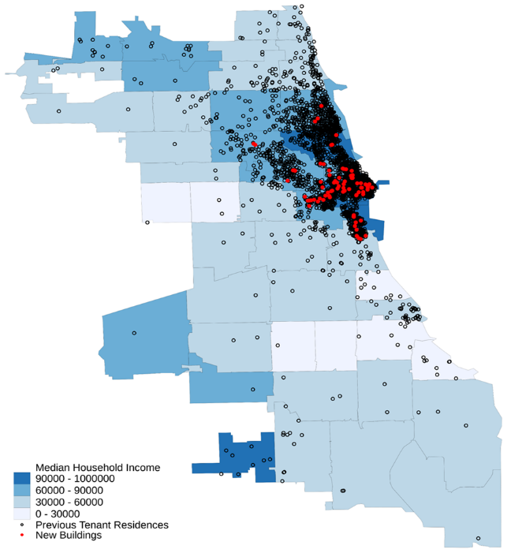
The First Round of the Chain—Residents of New Buildings

I identify 686 large new market-rate multifamily buildings in 12 large central cities and track 52,000 of their current residents to their previous building of residence. I then find the tenants currently living in those buildings and track them to their previous residence, iterating for six rounds. The below figure plots the locations of new buildings near downtown Chicago (in red), as well as the prior residences of current new building residents (in black). Even the first round of the chain reaches a far broader area of the city than the region in which the new buildings are concentrated.

Later Rounds of the Chain

I next examine that share of each round of the chain that originates in census tracts with below MSA-median income. About 20 percent of new building residents moved in from such neighborhoods, and that proportion rises steadily to 40 percent in round six. The share from tracts in the bottom 20% of income is lower, but it similarly increases as the chain continues. This illustrates that a short series of moves connects expensive new construction to lower-income areas, loosening the housing market in these neighborhoods.
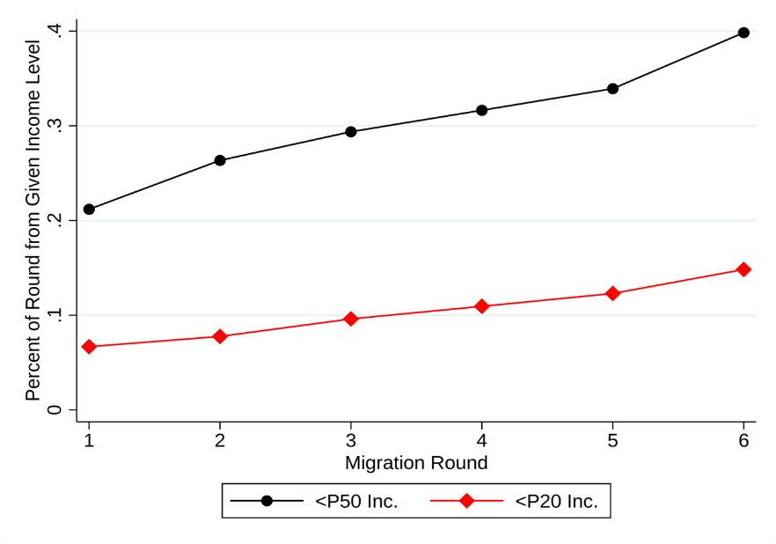

Implications

- Policies that increase market-rate construction are likely to improve affordability even for housing units that bear little similarity to the newly constructed units.
- Because these affordability effects operate by changing private market rents and prices, additional assistance programs will still be required for households who cannot afford to rent or purchase any private-market unit.

